**1. ER-Diagram Overview**

The **Entity-Relationship (ER) Diagram** for the AI Hotel Reservation System outlines the core data structure and relationships between key entities. The database is designed to support seamless user interactions, real-time bookings, and AI-driven recommendations while maintaining data integrity and performance.

**2. Key Entities**

1. **User**
   * Stores user profiles, authentication details, and personal information.
   * Linked to **Booking**, **Notification**, and **AI Recommendation** for personalized experiences.
2. **Hotel**
   * Contains hotel details (name, location, rating) and external API references.
   * Relates to **Room** (availability) and **Deal** (promotions).
3. **Booking**
   * Manages reservation records, check-in/out dates, and payment status.
   * Connects **User** and **Room** to track occupancy.
4. **AI Recommendation**
   * Stores AI-generated suggestions (e.g., hotel matches based on user history).
   * References **User** and **Hotel** to tailor results.
5. **Notification**
   * Handles alerts (booking confirmations, deals) with read/unread status.
   * Tied to **User** for targeted communication.

**3. Relationships**

* **One-to-Many:**
  + ***User →*** *Booking* (one user, multiple bookings).
  + ***Hotel →*** *Room* (one hotel, multiple room types).
* **Many-to-Many:**
  + ***Deal →*** *Hotel* (promotions apply to multiple hotels).
* **Why This Design?**
  + **Scalability:** Structured to accommodate future features (e.g., reviews, loyalty programs).
  + **Performance:** Optimized for high-frequency queries (e.g., real-time room availability checks)

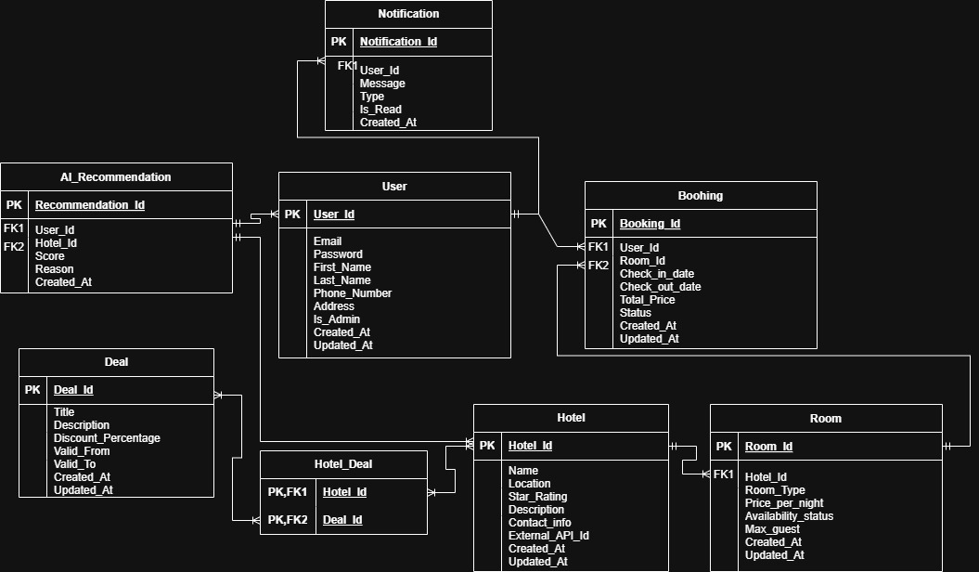

**Figure 1:** ER-Design for Hotel System Reservations.